OBJECTIVE 2: GR4ML MODELING

SMART RETAIL INVENTORY PREDICTION SYSTEM
=====================================================================

2. 1 BUSINESS VIEW

Introduction
The Business View describes how the Smart Retail Inventory Prediction System supports business objectives and stakeholder requirements. The system uses machine learning techniques to forecast future product demand and optimize inventory management decisions. By analyzing historical sales data, inventory records, seasonal trends, promotional activities, and customer purchasing behavior, the system helps retailers maintain optimal stock levels and improve operational efficiency.

Business Goals
The primary business goals of the Smart Retail Inventory Prediction System are:
• Reduce stockout incidents. • Minimize excess inventory and storage costs. • Improve demand forecasting accuracy. • Enhance customer satisfaction through better product availability. • Optimize replenishment and procurement planning. • Increase overall profitability and operational efficiency.

Stakeholders
Primary Stakeholders
- Retail Store Managers
- Inventory Managers
- Supply Chain Managers
- Warehouse Managers
Secondary Stakeholders
- Retail Business Owners
- Data Analysts
- Customers
- Suppliers and Distributors

Business Benefits
The proposed machine learning solution offers several business benefits:
• Better inventory planning and control. • Improved product availability. • Reduced inventory holding costs. • Faster and data-driven decision making. • Increased customer satisfaction. • Improved operational efficiency. • Increased profitability.

Business Challenges
Retail businesses operate in a highly dynamic environment where customer demand changes frequently due to seasonal trends, festivals, promotional campaigns, market competition, and economic conditions.
Traditional inventory management approaches often rely on historical averages and manual planning, which may not accurately capture changing customer behavior. As a result, businesses frequently experience inventory-related challenges such as overstocking and stock shortages.
Overstocking increases warehouse utilization, inventory carrying costs, and product wastage. Stock shortages negatively affect customer satisfaction and result in lost sales opportunities. Therefore, an intelligent forecasting system is required to predict future demand and support inventory planning decisions.

Explanation
The Business View illustrates the relationship between business objectives and machine learning capabilities. The forecasting model generates future demand predictions that help managers make informed inventory decisions. The resulting recommendations improve stock availability while reducing inventory-related costs.

Business View Diagram

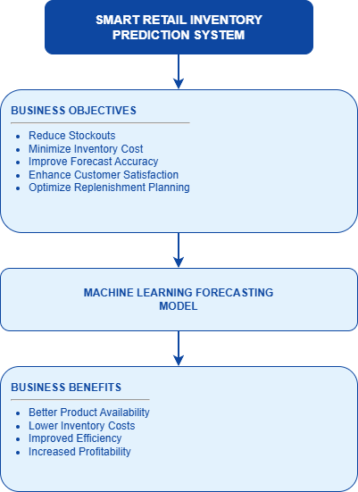

=====================================================================

2.2 ANALYTICS DESIGN VIEW

Purpose
The Analytics Design View describes how machine learning models are designed to solve the retail inventory forecasting problem.

Analytics Objective
The objective is to predict future product demand using historical sales information, inventory records, seasonal trends, promotional activities, and customer purchasing patterns.
Machine Learning Task
Learning Type: Supervised Learning
Problem Type: Regression
Prediction Target: Future Product Demand

Input Features
Historical Sales Features
- Daily Sales Quantity
- Weekly Sales Trends
- Monthly Sales Trends
- Previous Demand Patterns
Inventory Features
- Current Stock Levels
- Inventory Status
- Reorder Levels
Promotional Features
- Discount Percentage
- Marketing Campaigns
- Promotional Events
Seasonal Features
- Month
- Quarter
- Holiday Indicators
- Festival Seasons

Product Features
- Product Category
- Product Price
- Product Popularity

Target Variable
Future Product Demand (Sales Quantity)
Candidate Machine Learning Models
The following machine learning models will be evaluated:
- Linear Regression
- Random Forest Regressor
- Gradient Boosting Regressor
- XGBoost Regressor
- LSTM Neural Network

Analytics Workflow
The analytics process begins with collecting sales, inventory, and promotional data. After preprocessing and feature engineering, machine learning algorithms are trained using historical data.
The trained models generate future demand forecasts which are subsequently used to recommend reorder quantities and identify potential stockout risks.

Analytics Design Diagram

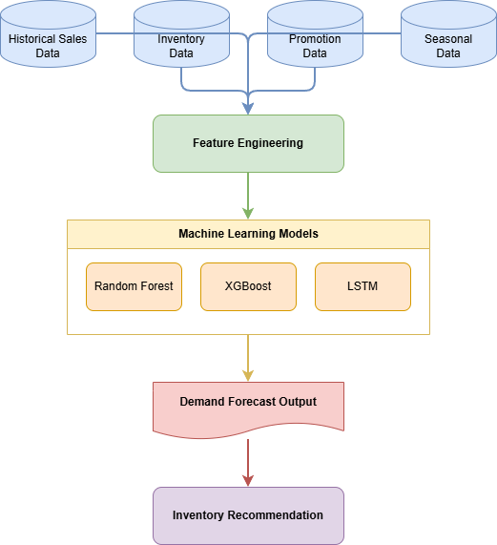

Model Selection Rationale
Different machine learning algorithms offer different levels of forecasting capability.
Linear Regression serves as a baseline model and provides interpretability.
Random Forest and Gradient Boosting algorithms capture nonlinear relationships in retail data and generally provide better forecasting performance.
XGBoost is selected as a strong candidate because of its scalability, efficiency, and ability to handle large datasets.
LSTM neural networks are particularly useful when long-term sequential patterns exist in historical sales data.

Evaluation Metrics
The forecasting models will be evaluated using:
• Mean Absolute Error (MAE)
• Root Mean Squared Error (RMSE)
• Mean Absolute Percentage Error (MAPE)
• R-Squared Score (R²)
These metrics collectively help identify the best-performing forecasting model.
=====================================================================

2.3 DATA PREPARATION VIEW
Purpose
The Data Preparation View describes the collection, cleaning, transformation, and preparation of data before machine learning model development.

Data Sources
Sales Database
Contains:
- Product ID
- Sales Quantity
- Sales Date
- Store ID
Inventory Database
Contains:
- Current Stock Levels
- Inventory Status
- Reorder Points
Promotion Database
Contains:
- Discount Information
- Promotional Campaign Details
External Data Sources
Contains:
- Holiday Calendars
- Festival Information
- Seasonal Events

Data Cleaning Activities
The following preprocessing activities are performed:
- Missing Value Treatment
- Duplicate Record Removal
- Outlier Detection
- Data Consistency Validation

Importance of Data Preparation
Data preparation is one of the most critical stages in the machine learning lifecycle. Poor-quality data can significantly reduce forecasting accuracy and negatively impact model performance.
Proper preprocessing ensures that the training dataset is reliable, consistent, and suitable for machine learning applications.

Data Transformation
Encoding Techniques
- Label Encoding
- One-Hot Encoding
Scaling Techniques
- Min-Max Scaling
- Standardization

Feature Engineering
Several additional features are generated from raw data:
- Day of Week
- Month
- Quarter
- Holiday Indicator
- Rolling Average Sales
- Lag Sales Features
These engineered features improve forecasting accuracy by capturing hidden demand patterns.
Dataset Splitting
Training Dataset: 70%
Validation Dataset: 15%
Testing Dataset: 15%

Data Quality Assurance
To maintain data quality, the following validation activities are performed:
• Missing value identification and treatment.
• Duplicate record removal.
• Data type verification.
• Outlier correction.
• Consistency validation across data sources.

Data Preparation Diagram

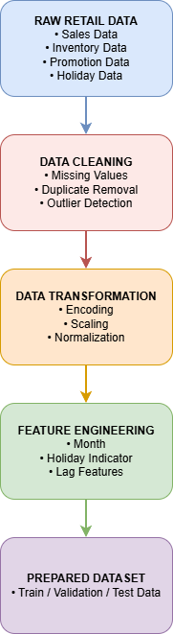

=====================================================================

2.4 GR4ML OVERVIEW

Overall GR4ML Workflow
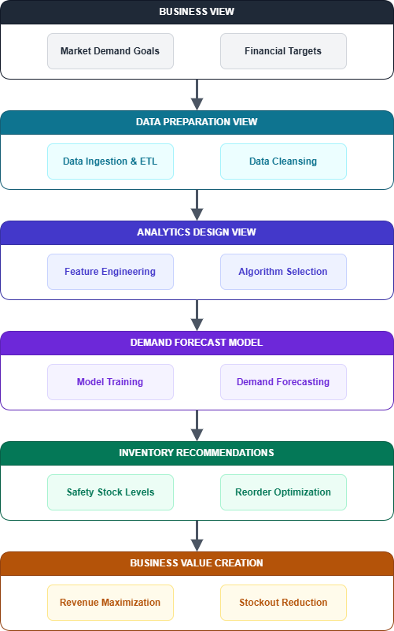
================================================================

2.5 BENEFITS OF GR4ML
The GR4ML framework provides a structured approach for designing machine learning systems.

Key Benefits:
• Better communication among stakeholders. • Improved project planning and management. • Clear traceability from business goals to machine learning solutions. • Improved scalability and maintainability. • Reduced implementation risks. • Enhanced system documentation.
====================================================================

2.6 CONCLUSION
The Smart Retail Inventory Prediction System demonstrates how machine learning can be used to solve real-world inventory management challenges. The GR4ML framework systematically connects business objectives, data preparation activities, and analytics design decisions.
The resulting forecasting model enables retailers to make proactive inventory decisions, reduce operational costs, improve product availability, and enhance customer satisfaction.
By integrating machine learning into inventory management processes, organizations can achieve greater operational efficiency, improved profitability, and long-term business sustainability.
=====================================================================

